presents
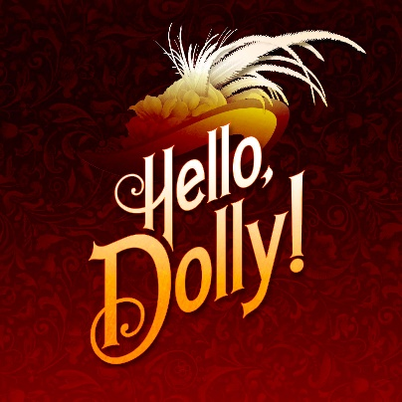
Hello, Dolly- This musical adaptation of Thornton Wilder's hit play The Matchmaker bursts with humor, romance, energetic dancing and some of the greatest songs in musical theatre history. The romantic and comic exploits of Dolly Gallagher-Levi, turn-of-the-century matchmaker and "woman who arranges things"

Prairie Lakes Theatre
515 E. Thacker St. Des Plaines, Il 60016
7:30 PM Fridays & Saturdays
2:00 PM Sundays

November 3-4-5 and | 10-11-12, 2023

Ticket Order Form
Show Date(s) | # Adult  $22 | # Senior (65+)/  Children (2-14)  $20 |  |  |  | Check if Wheelchair Seating Required
 |  |  |  |  |  | How many? ______
TOTAL AMOUNT $ Group rates available: call 773-736-2490

Select Payment Method: Credit Card (fill out info below) Check: (number )
Make checks payable to the Rising Stars Theatre Company

Credit Card | Visa MC CC# Exp Date:
Info | CVV Code: (3-digit number on back of card): Cardholder Name:

Name
Address
City |  | State |  | Zip
Phone |  | E-mail

Select Receipt Method: | MAIL THIS FORM WITH PAYMENT OR CC INFO ENCLOSED TO:  The Rising Stars Theatre Company  P.O. Box 232, Franklin Park, IL 60131
Mail (enclose stamped, addressed envelope)
Will Call under (name)
Email to (address)

ORDER TICKETS ONLINE! Visit our website at www.risingstarschicago.com.
Online orders are payable by credit card only. For information call 773-736-2490 or email: risingstarstc@gmail.com

